A Report on
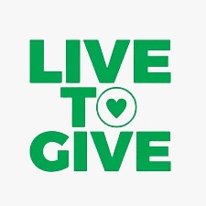
Community Service At

LIVE TO GIVE FOUNDATION
Worli, Mumbai – 400018
Submitted By
Shayan mandrekar
SAP ID: 70382200006
Under The Guidance Of
Prof. Cynthia Dias
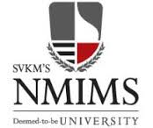

Mukesh Patel School of Technology & Management Engineering
Department of __Data Science___
Vile Parle (w), Mumbai- 400056
Community Service Period
From ___01/06/25____to ______21/06/25_____

Service Completion Certificate

This is to certify that Mr./Ms. ____shayan mandrekar ______
SAP ID.___70382200006_________ student at the institute Mukesh Patel school of technology management & engineering, studying in Semester VII of B.Tech. Integrated_____Data Science____________ engineering program has successfully completed consecutive three weeks of community service in our organization/department, at _________Live to Give Foundation___________ location.
He/ She has undertaken volunteer community service during the Period: from _01/06/25________ to __21/06/25_______ in our organization and completed the service tasks/activities allocated to him/her.

_____________________________
Signature of the Organization Mentor

Seal/ Stamp of
organization

No Objection Certificate

This is to certify that Mr./Ms. ___shayan mandrekar______ (SAP ID._70382200006__________) student of Mukesh Patel School of Technology Management & Engineering, has successfully completed consecutive three weeks of community service from __01/06/25_____ to ___21/06/25_______________, at _____Live to Give Foundation_________ location and has completed the tasks given to him/ her during the service period. He/ She has informed us that the Report is needed to be submitted in partial fulfillment of the requirement for the supplementary course on community services. He/ she has been allowed to include the relevant information (photographs/brochures/templates/videos etc.) taken during the service period at our organization in the final report and presentation. We have no objection for using them for academic purpose.

_____________________________
Signature of the Organization Mentor

Seal/ Stamp of
organization

Certificate of Submission

This is to certify that the report entitled ‘Community Service at ‘_____Live to Give Foundation___’ is a bonafide work of ___shayan mandrekar______ (SAP ID._70382200006__) and submitted in semester (VII) for the partial fulfillment of the requirement for supplementary course on community services at, Mukesh Patel School of Technology Management & Engineering, Mumbai during the academic year 2024-2025.

Signature:

Faculty Coordinator Head of Department Dean

Declaration

I, ______shayan mandrekar ______, SAP ID._____70382200006_____ a student of Semester (VII) of B.Tech. Integrated program in ___Data Science_____ engineering humbly submit that I have completed from time to time the community service course work as described in this report by my own skills and served from ___01/06/25_____________ to ____21/06/25________ in ____Live to Give Foundation______. I have not copied the report or it’s any appreciable part from any other literature in contravention of academic ethics. I declare that this written submission represents my ideas in my own words. I also declare that I have adhered to all principles of academic honesty and integrity and have not misrepresented or fabricated or falsified any idea/data/fact/source in my submission. I understand that any violation of the above will be the cause of disciplinary action by the Institute and can also evoke penal action from the sources which have thus not been properly cited or from whom proper permission has not been taken when needed.
Date: 25/08/25
Place: Mumbai
Name & Signature of the Student: shayan mandrekar

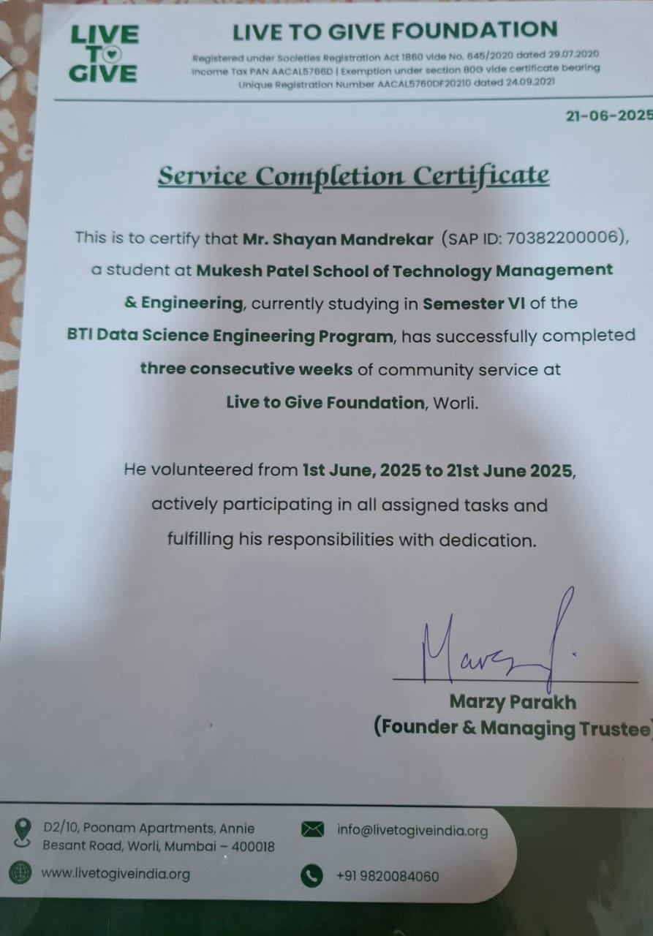
- Cover Page
- Service Completion Certificate
- No Objection Certificate
- Certificate of Submission
- Declaration
Table of Contents | Page No.
Chapter-1  - Introduction about the Organization  (History, Service activities, projects/scheme run by the organization)  - Introduction about the allocated service activity | 1-3
Chapter-2  - Discussion about the different service tasks undertaken.  - Discussion about any technological (software/ hardware) solution employed for carrying out service activities | 4-8
Chapter-3  - Discussion about the experiences gained, skills acquired, and changes felt in outlook toward the self and the community | 9-12
Chapter-4  - Learning gains during the community service | 13-14
Chapter-5  - Conclusion & Future Plan of Action | 15
References | 16
- Appendix (Include Photographs, Brochures, Testimonials about work)

Chapter 1 :-
About Live to Give Foundation
The Live to Give Foundation is a CSR and 80G registered non-profit that operates mainly through WhatsApp groups. It was created to make social service simple, transparent, and community-driven, allowing citizens to help others without the barriers of traditional NGO structures.
Members of the foundation—ranging from doctors, NGO founders, and volunteers to everyday citizens—work together to verify, support, and follow up on cases of individuals in need. Unlike many organizations, Live to Give runs without paid staff, which ensures that all contributions go directly to beneficiaries. Over the years, the foundation has provided aid in areas such as medical support, education, ration supplies, and emergency relief.
Introduction to the Allocated Activity
During my three-week service period, I was assigned two key responsibilities:
- Collecting Testimonial Videos: Contacting beneficiaries who had received aid in the past, recording their experiences, and editing their videos for the foundation’s use. These testimonials were important to encourage new beneficiaries to seek help and to inspire donors by showing the real impact of their contributions.
- Connecting with NGO Founders: Engaging with small NGOs that required additional assistance from Live to Give. This activity helped identify opportunities for collaboration and resource sharing, expanding the foundation’s outreach and impact.
These activities gave me direct exposure to the foundation’s working style and the important role of communication, documentation, and collaboration in building trust and extending support to communities in need.

Chapter 2 :-

Service Activity Log –
Week 1 –
- 01/06/2025:
The first day began with an orientation session led by Mr. Marzy Parakh and Mrs. Lourdes Alexander, who introduced me to the foundation’s mission and working model. I was briefed about my responsibilities for the next 21 days, mainly focused on testimonial collection and outreach. Later, I studied previous beneficiary records to understand the kind of aid provided and its overall impact, which gave me a clearer picture of the foundation’s work.
- 02/06/2025:
I initiated communication with past beneficiaries by making phone calls and recording their feedback. The conversations covered needs related to education, ration, hospital funding, and other essentials. While documenting these details, I ensured data privacy and ethical handling. I also categorized testimonials by urgency and type, which helped streamline case management for the foundation’s team.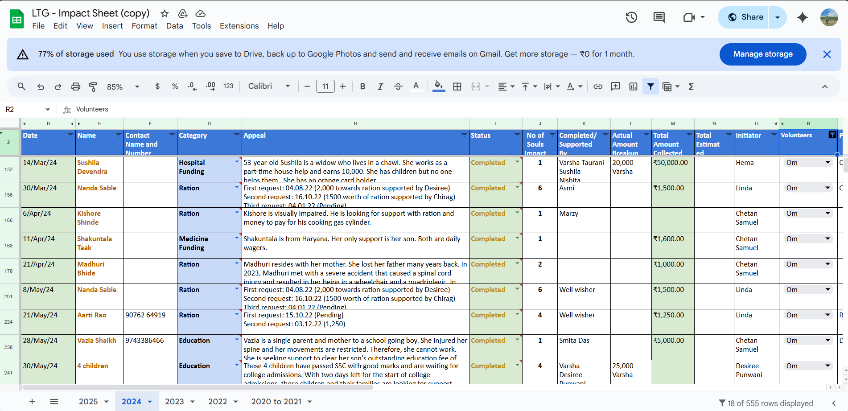
Fig. 1. Google Sheet of Beneficiary Details
- 03/06/2025:
I spent the day reviewing old testimonial videos stored by the foundation to understand the style, tone, and quality expected. While doing so, I noted areas where improvements could be made, such as clearer subtitles, better framing, and concise storytelling. This exercise gave me practical insights into how impactful content can inspire donors and encourage more people in need to reach out for help.
- 04/06/2025:
Focused on in-depth conversations with many beneficiaries, three of whom had urgent requirements. Compiled detailed stories intended for upcoming social media campaigns. Recommended improvements to the type of Instagram posts which should be posted and informed them for prominently displaying these testimonials and real-life impact stories.
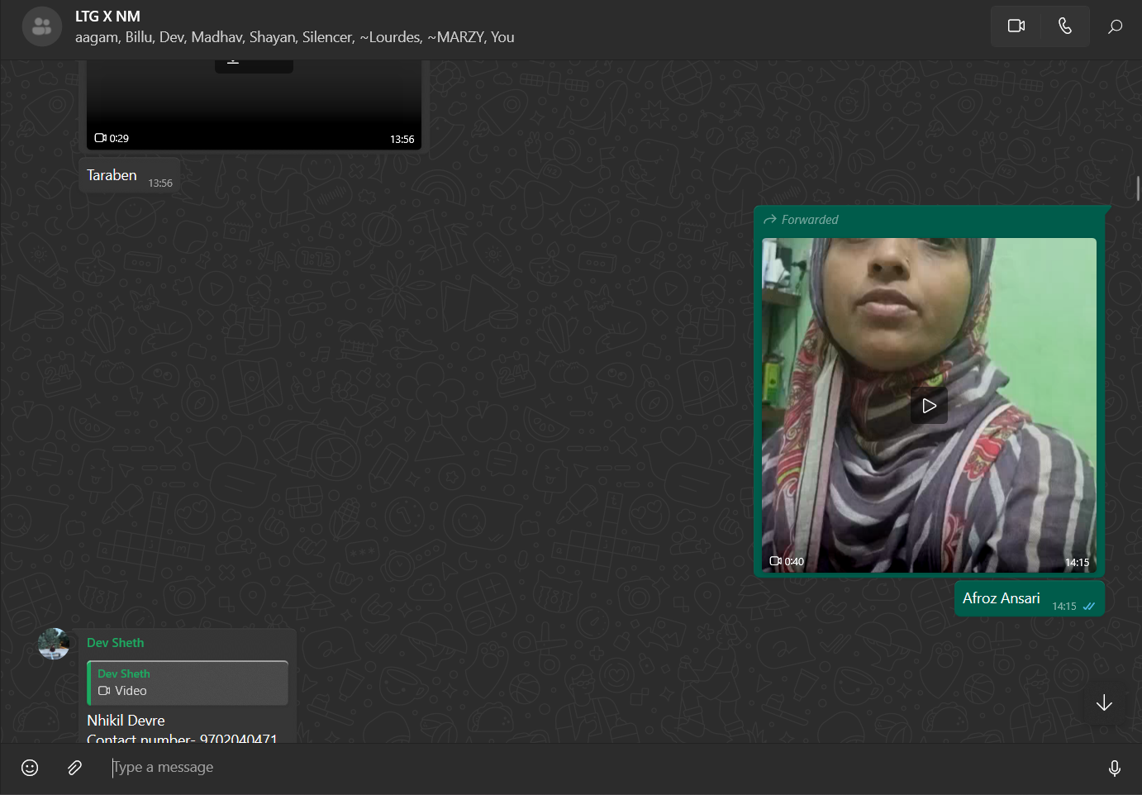
Fig. 2,3,4. Testimonial Videos

- 07/06/2025:
I reviewed and began editing raw testimonial videos received from beneficiaries. While working on them, I also clarified certain narratives with beneficiaries to ensure the stories were accurate and impactful.

Week 2 –

- 08/06/2025:
I edited and subtitled testimonial videos, focusing on privacy and clarity. The aim was to condense long stories into emotional, engaging reels suitable for social media outreach.
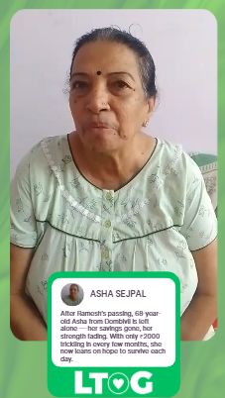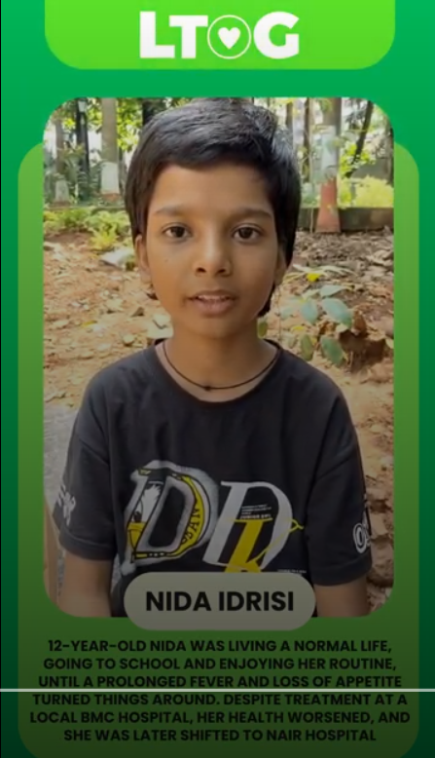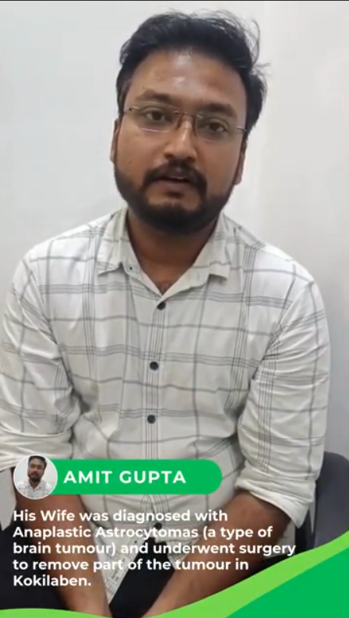
Fig. 5. Edited Beneficiary Testimonial Video

- 09/06/2025:
Coordinated with the organization’s digital team to schedule video releases across platforms like Instagram. Offered creative feedback on video layouts to maintain consistency with branding and messaging.
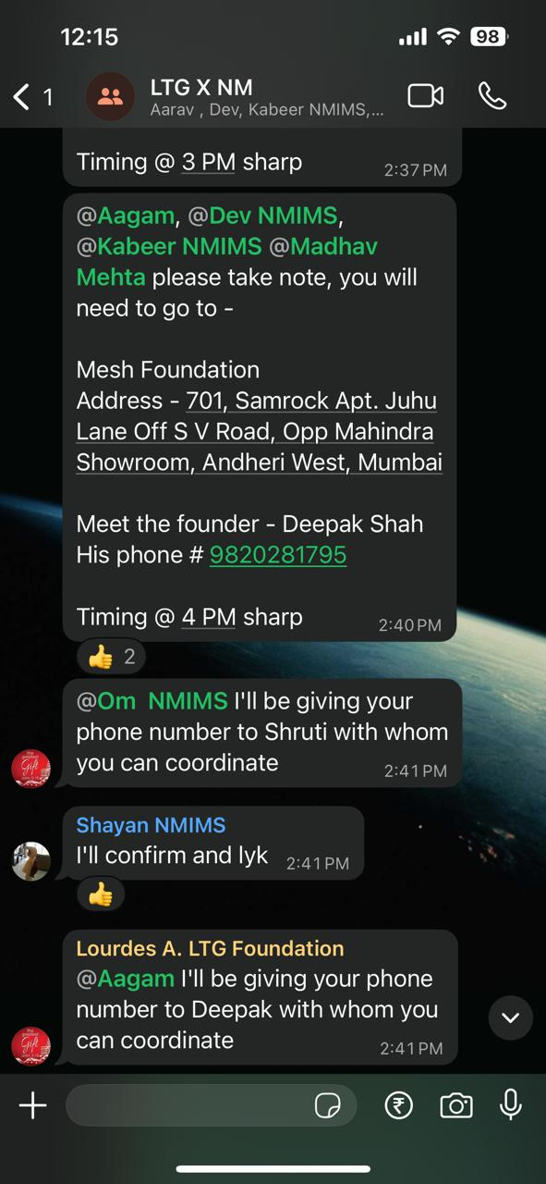
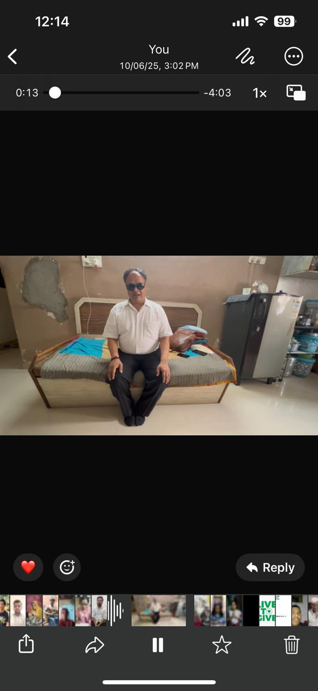
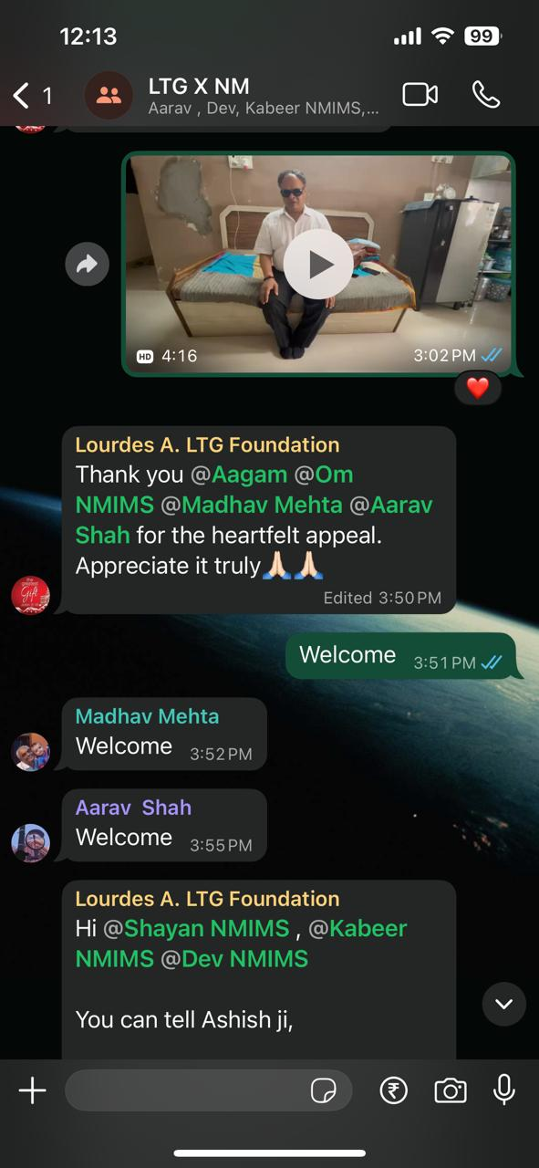
- 10/06/2025:
On this day, I met a representative from the MESH Foundation, an organization dedicated to supporting visually impaired individuals by offering them jobs and sustainable livelihood opportunities. Their inclusive model ensures that people with disabilities are treated with the same dignity and respect as everyone else. The interaction emphasized how true empowerment lies in creating systems where ability is valued over disability, setting an example for society at large.

Fig. 6,7,8. Proof of meeting with NGO founders

- 12/06/2025:
I met with the founders of two small NGOs to discuss their challenges and explore how Live to Give could support them. The meetings focused on collaborative campaigns in education and healthcare to maximize impact.

- 13/06/2025:
On this day, I called a few of our beneficiaries, and one story that stayed with me was of Raju Sheikh, a daily wage labourer from Sakinaka. His 8-year-old daughter, Shahida, has a hearing disability and needs batteries for her cochlear device costing ₹28,758, on top of a ₹7,000 monthly rent. Listening to him made me realize how I often worry about small things, while people like Raju face far bigger struggles yet find the strength to keep going. It humbled me and reminded me why our work matters so deeply.

Week 3 –

- 14/06/2025:
I assisted a colleague in creating an introductory video about Live to Give Foundation. My role was mainly in content writing and structuring the message so the video clearly conveyed the foundation’s purpose and impact.
- 16/06/2025:
I followed up with a few beneficiaries to check on their progress after receiving aid. These conversations helped in tracking the real impact of support provided and also highlighted areas where they still needed assistance.
- 19/06/2025:
I concluded outreach by collecting the final round of testimonials and editing them into clear, impactful stories. I also prepared summary reports for the foundation and documented updates from students who had received educational aid, such as admissions and scholarships.
- 20/06/2025:
Visited Tata Cancer Hospital in Dadar East, where our NGO has been consistently providing aid and daily grocery support for cancer patients and their families. During the visit, I got to closely observe the difficult realities faced by people who travel from different parts of India to Mumbai for treatment. Many are forced to live in small chawls under tough conditions, struggling not only with the emotional and financial burden of the disease but also with the lack of proper nutrition required to fight it effectively.
Through interactions with patients and caregivers, I understood how these challenges add to their suffering and make recovery harder. Our NGO’s initiative of supplying groceries and essential items has been a lifeline for them, ensuring they receive balanced meals and some relief from the overwhelming daily expenses. It was heartening to see how this support restores hope and strength, and how small acts of care can make a big difference in their journey.
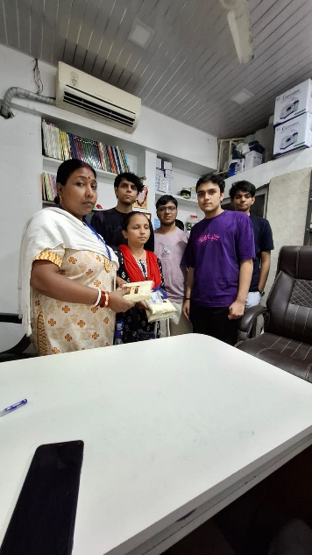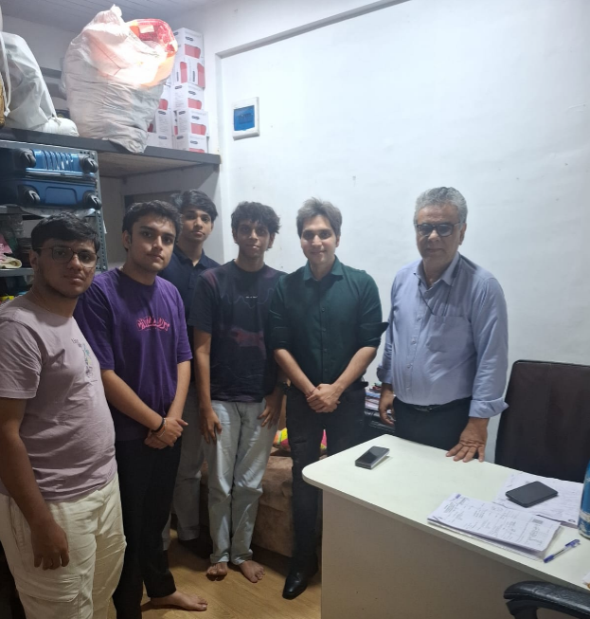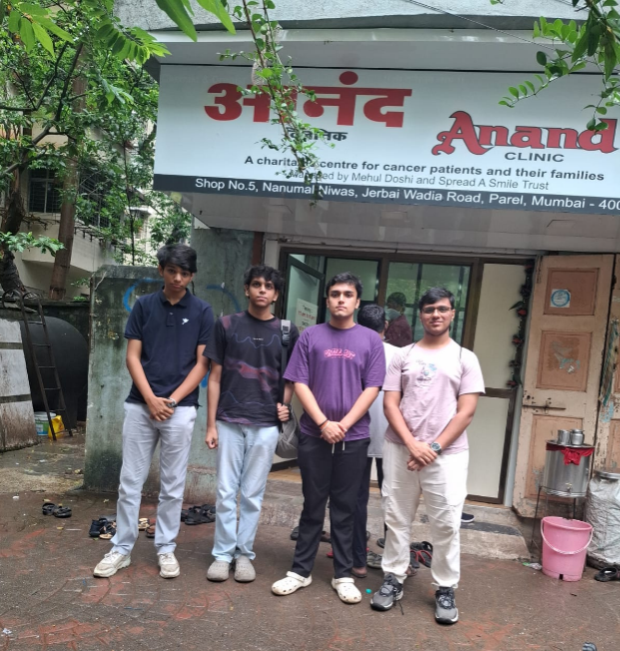

- 21/06/2025:
I created and presented a summary of my work and learnings to the foundation’s leadership team. The presentation highlighted key metrics such as the number of beneficiaries reached, videos edited, and impact stories collected, along with feedback for improving beneficiary communication.

Technological Solutions :-

1. Google Workspace (Forms)
- Purpose: Documentation, data recording, and testimonial tracking.
- Application: Google Sheets used to log beneficiary details, aid received, and testimonial status.
2. Canva
- Purpose: Visual content creation for social media.
- Application: Enabled me to design templates, and social media posts from testimonials. Helped maintain brand consistency and increase engagement on Instagram.
3. Adobe Premiere Pro
- Purpose: Video editing for beneficiary testimonials.
- Application: Used to trim, subtitle, and enhance beneficiary videos. Helped in converting unedited stories into engaging, donor-facing reels while preserving message clarity and data sensitivity.

Chapter 3 –
Skills Developed
- Verbal and Written Communication
Regular interactions with beneficiaries, mentors, and partner NGOs improved my professionalism and confidence in both spoken and written communication. I learned to conduct sensitive conversations with vulnerable groups, sharpened my interviewing and follow-up skills, and enhanced my ability to prepare clear, structured reports.
- Video Editing and Storytelling
I gained practical knowledge of tools like Adobe Premiere Pro and Canva, which enabled me to transform raw testimonials into compelling stories. I also understood the importance of ethical representation, accurate subtitling, and crafting narratives that resonate with both donors and the wider community.
- Content and Data Management
By organizing and archiving testimonial videos, WhatsApp audios, and photos, I created a systematic bilingual repository that can be used for future reference. I also developed methods for standardizing formats, which improved accessibility, efficiency, and consistency across the foundation’s digital assets.
- Collaboration and Networking
Engaging with leaders and founders of other NGOs gave me exposure to diverse operational models and advocacy strategies. I learned how collaboration and resource-sharing between organizations can multiply impact and reach more beneficiaries.
- Problem-Solving and Organization
Through day-to-day tasks, I developed structured processes for identifying urgent cases, coordinating aid, and refining testimonial collection. Tools such as checklists and workflows helped increase efficiency and reduce delays in communication.
- Empathy and Active Listening
Speaking with people facing extreme hardships taught me the value of patient listening and compassion. I learned how to balance emotional sensitivity with professionalism, ensuring that conversations remained supportive while still focused on problem-solving.
- Adaptability and Cultural Sensitivity
By interacting with people from diverse regions and backgrounds, I became more adaptable and learned to respect cultural differences and community-specific needs. This experience enhanced my ability to communicate across languages and contexts with greater ease.

Experiences Gained
- Built trust with beneficiaries by listening to their struggles and explaining the mission of Live to Give Foundation in simple, reassuring terms.
- Conducted interviews with NGO founders and observed firsthand how grassroots organizations function, manage resources, and collaborate.
- Edited and produced impactful testimonial videos, which gave me a deeper appreciation of how storytelling can inspire action among donors and beneficiaries alike.
- Witnessed the struggles of cancer patients and their families in Mumbai, which gave me a clearer perspective on the importance of sustained aid in healthcare and nutrition.
- Learned about the operational side of NGO work—data collection, donor communication, and systematic archiving—which highlighted the value of organized systems in sustaining social service.
- Improved my ability to communicate bilingually (Hindi, Gujarati, English), enabling me to connect with a wider group of beneficiaries and stakeholders.

Changes Felt
- Developed a greater sense of gratitude for the stability and privileges in my own life after witnessing the daily struggles of others.
- Cultivated empathy and compassion, not just within the NGO setting but also in everyday interactions.
- Improved my technical, communication, and interviewing skills through consistent practice and mentorship.
- Became more socially aware of challenges such as lack of healthcare access, nutrition gaps, and financial struggles that many communities face.
- Learned the value of teamwork and collaboration, realizing that lasting change is possible only through collective effort.
- Gained confidence in maintaining emotional balance and professionalism, ensuring that compassion is translated into meaningful support.
- Adopted a solution-oriented mindset, seeing obstacles as opportunities to innovate and design sustainable ways forward.

Learning Gains
- Enhanced Communication Skills – Improved clarity, empathy, and professionalism while interacting with beneficiaries and mentors.
- Practical Video Editing – Learned to use tools like Adobe Premiere Pro and Canva to create impactful testimonial videos.
- Interviewing Techniques – Gained confidence in conducting sensitive conversations and gathering meaningful stories.
- Collaboration Skills – Understood the value of teamwork and cross-organization cooperation to achieve greater impact.
- Teamwork and Coordination – Learned how to work effectively within a group, manage responsibilities, and support collective goals.
- Problem-Solving Abilities – Developed systematic ways to handle urgent beneficiary cases and improve workflow efficiency.
- Empathy and Active Listening – Learned to understand and respect the emotions and struggles of people while maintaining professionalism.

Chapter 5
Conclusion
The three-week community service with Live to Give Foundation proved to be a deeply enriching experience, both personally and professionally. Actively engaging in beneficiary outreach, testimonial collection, video editing, and NGO collaboration not only supported individuals in need but also contributed to improving the foundation’s efficiency and transparency.
By implementing structured documentation and refining communication processes, I witnessed how data-driven practices can enhance aid delivery. Similarly, creating impactful digital content helped strengthen the foundation’s presence, inspiring greater trust among donors and encouraging more beneficiaries to seek support.
Beyond skill development in communication, content management, and storytelling, this journey provided invaluable insight into the struggles of marginalized communities. It reinforced the idea that even small, consistent contributions can create meaningful and lasting change.

Future Plan of Action
Building on this experience, I intend to remain actively engaged in community service and apply the skills I have gained—especially in communication, technology, and storytelling—to amplify impact. My focus will be on:
- Continuing to volunteer time for NGOs and grassroots organizations.
- Using digital tools to design awareness campaigns and impact stories that encourage wider participation.
- Supporting individuals in need to the best of my capabilities, with empathy and professionalism.
This service has inspired me to integrate social responsibility into my personal and professional journey, ensuring that the spirit of “giving back” remains a continuous part of my life.

**** End of Report ****

